Seventh Grade Oral Report Project:

American Revolution

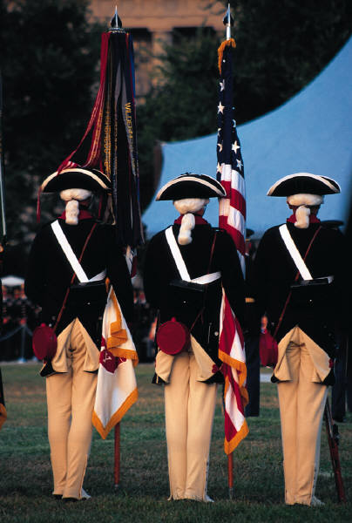

Assignment: 1. For your report you must investigate a person of historical significance related to the American Revolution (either prominent or obscure). The person you select must be a person you find interesting and want to learn more about. You are then going to present your report orally to the class.

2. You are going to assume the identity of the person you’ve read about. You will make yourself look as much like the person as possible. You may use clothing, makeup, and necessary props, charts, and other materials to make your speech a success.

3. You are going to make a speech about that person’s life as if you were that person. Your speech must be 2-5 minutes long and include index cards to organize information.

4. You are going to write a 5 paragraph essay for English and Social Studies. This essay will discuss conflict and the Revolutionary war.

Your presentation and report must contain the following information:

a. Who are you? When were you born? Died?
b. Why are you important enough to be talked about today?
c. What are your proudest accomplishments?
d. What were your moments of despair?
e. What personal qualities did you possess that resulted
in your success? Give examples.
f. Discuss any family members who influenced your life.
Include any other information that you feel is necessary.



Grading
This project will be scored on a scale of 100 points.

Rubric
a. Researched information, relevant content……………..50 points
b. Length of presentation……………………………….…..10 points
c. Use of index cards………………………………………..10 points
d. Creativity, use of props…………………………………..15 points
e. Delivery, body language, eye contact, voice quality…..15 points

Due date: February 28th 2006

Suggested sources: Use textbook, library resources, Internet sites

No cheating will be tolerated, and any student who commits plagiarism will receive a zero for the report.

Plagiarism: Representing the words or ideas of another as one’s own in any academic exercise.
- Failing to enclose a direct quotation from a reference source within quotation marks.
- Paraphrasing the words or ideas of another person without proper citation or documentation.
Good luck and enjoy the assignment!

